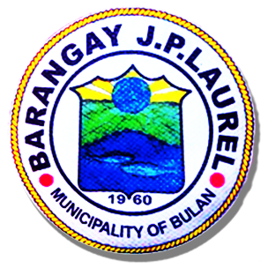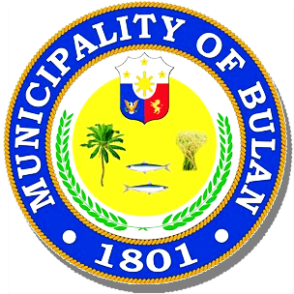Republic of the Philippines

**MUNICIPALITY OF BULAN**

Sorsogon  SORSOGON

**BARANGAY J.P. LAUREL**

OFFICE OF THE PUNONG BARANGAY

**BARANGAY Business Clearance**

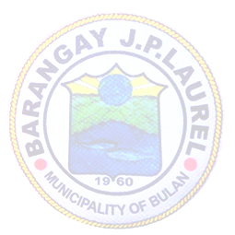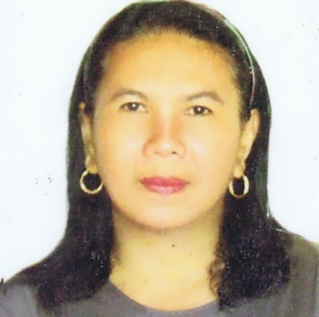

**BARANGAY OFFICIALS**

**NORIE G. CAÑEZAL**

**Punong Barangay**

**BARANGAY KAGAWAD**

**MARY JANE G. ESQUILLO**

**JUNIE G. BREZUELA**

**LERMA O. GRANADIL**

**RENAN G. GOLLOSO**

**VENER P. BERANIA**

**FLORENCE M. SUS**

**JOSEPH H. ALMOGUERA**

**SK CHAIRMAN**

**RONNEL G. GUETA**

**JONNA B. AGNE**

Barangay Secretary

**AGNES R. JUAB**

Barangay Treasurer

**LILIBITH G. GUETA**

**_____________________________________**

**NAME**

**PUROK 1 J.P.LAUREL,BULAN,SORSOGON**

**_____________________________________**

**ADDRESS**

**SARI-SARI STORE**

**_____________________________________**

**KIND OF BUSINESS**

O.R. No:­­­­­­­­­­_____________

Issued on:_____________

Issued at:______________

.

Approved:

Attested by: ***NORIE G. CAÑEZAL***

Punong Barangay

***JONNA B. AGNE***

Barangay Secretary

